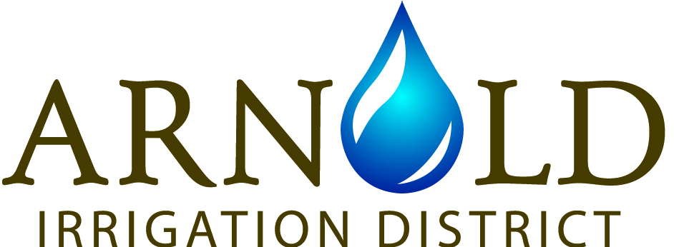

19604 Buck Canyon Rd., Bend, OR 97702

Phone: 541-382-7664 Fax: 541-382-0833

FACILITY USE AGREEMENT

Name of User/Business/Group ("User"):

Phone Number: Email:

Address:

Name of Requested Facility:____________________________________

Date(s) of Use: ______________________________________________

Description of Activity: _____________________________________________________ ("Activity")

- Indemnification: In consideration for use of the Arnold Irrigation District’s ("AID") property, User agrees to hold harmless, waive, release, indemnify, defend, and discharge AID from all liability and claims arising from User's use of the AID's property. User agrees to these actions to the fullest extent allowed by law, which includes liability and claims arising from AID’s negligent acts. "AID" includes its Board of Directors, including the individual members thereof, and its officers, agents, employees, volunteers, and representatives. "Liability and claims" means demands for any value or benefit, such as lawsuits, tort claims, insurance claims, causes of action, fines, fees, and costs (e.g. medical costs and attorney fees). User certifies and represents that it has the legal authority to waive, discharge, release, and hold harmless the released parties on behalf of itself and its members, employees, agents, contractors, suppliers, or guests.

- Insurance: User agrees to carry, maintain, and provide proof of general liability insurance coverage with limits of not less than $1 million per occurrence and to name AID as a named insured under the general liability insurance policy.

- Property Damage: User agrees to reimburse AID for damage to AID's property that is caused by User and User's members, employees, agents, contractors, suppliers, or guests. As used in this agreement, “Property” includes any property or equipment owned by AID and utilized by User as a result of this agreement.

- Alteration, addition, or improvement: User shall not make alterations, additions, or improvements to Property. If User makes an alteration, addition, or improvement in breach of this agreement, then AID in its sole discretion may require User to remove the alteration, addition, or improvement and restore the Property to its original condition at User’s expense. These expressly stated remedies are in addition to all other available remedies.

- Maintenance, Cleanup, Repairs: At User's sole expense, User agrees to maintain, clean up, and repair Property in an equal or better condition than when it was received. As determined in AID's sole discretion, User agrees to compensate AID for any maintenance, cleanup, or repair required as a result of User's use of any Property.

- Right of Entrance. AID retains the right to enter any Property at all times during the life of this agreement.

- Accessibility: AID warrants that the Property complies with all applicable regulations and guidelines of the Americans with Disabilities Act. AID has made every effort to make its premises accessible by removal of barriers wherever reasonable and has provided alternative services wherever barriers cannot be reasonably removed. User shall be responsible for compliance with the ADA in connection with User’s use of any Property.

- Anti-Discrimination Policy: User warrants that it does not discriminate on the basis of race, color, creed, national origin, sex, sexual orientation, or any other protected status. AID reserves the right to deny use of AID facilities to groups that do not comply with AID's anti-discrimination policy.

- Bloodborne Pathogens: User agrees to adhere to the federal and state OHSA standards pertaining to bloodborne pathogens and any necessary clean-up of blood or other body fluids.

- AID's Name/Logo: All uses of AID's name or logo must be approved in writing by AID prior to use. User shall not state or imply that AID sponsors or endorses User or is responsible for User.

- AID's Policies: User agrees to follow all applicable laws and regulations, including AID rules and policies (“laws”). If at any time the User violates any laws, then the User shall either immediately discontinue use of the Property or immediately surrender the Property upon demand of AID.

- Modification: No modification, amendment, or alteration to the terms or conditions contained herein shall be effective unless contained in a written document and signed by AID.

- Severability Clause: This agreement is intended to be as broad and inclusive as is permitted by law. If any provision or any part of any provision of this agreement is held to be invalid or legally unenforceable for any reason, the remainder of this agreement shall not be affected thereby and shall remain valid and fully enforceable.

- Waiver: Failure by AID to enforce any provision of this agreement shall not be deemed a waiver of the provision or modification of this agreement. A waiver by AID of any breach of a provision of this agreement shall not be deemed a waiver of any subsequent breach and shall not be construed to be a modification of the terms of this agreement.

User certifies to have read this document and fully understand its contents.

Date: Month ____________________ Day _______, 2019

Signature of User or User's Authorized Representative:

